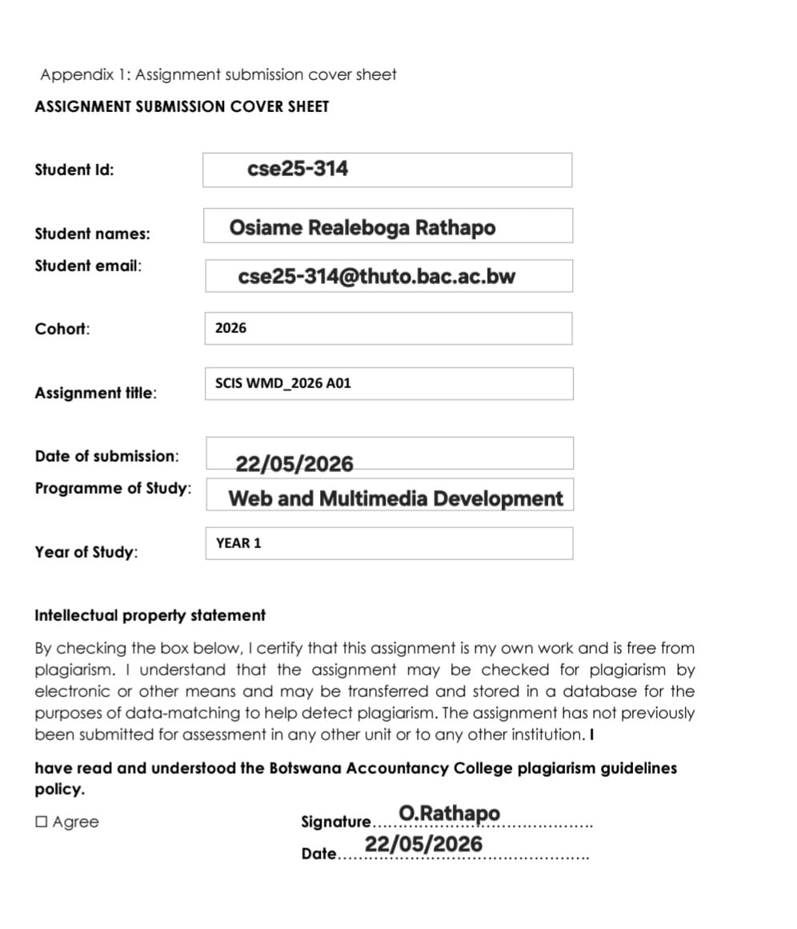

- Website Specifications
About us:
We are a dedicated food-tech platform designed specifically for the tertiary education landscape in Botswana. By digitizing the traditional meal plan, we bridge the gap between local campus kitchens and students at institutions like UB and BAC.
Our platform offers a recurring 30-day "Lunch Only" subscription, allowing students to secure their daily meals through integrated local payment solutions like Orange Money, FNB, and Pula transfers. We aren't just a website; we are a logistics partner committed to reducing queues, eliminating payment friction, and ensuring every student has access to a nutritious meal without the midday stress.

  - Objective and goals
- Primary Objective: To digitize and automate the meal subscription process, reducing manual administrative tasks and paperwork by approximately 40%.
- Business Goals: To drive customer retention through a seamless 30-day recurring "Lunch only" cycle and to scale the business by expanding its reach to multiple tertiary institutions (such as UB and BAC) through a single, centralized digital platform.
  - Target Audience
- Demographics: Tertiary students in Botswana (aged 16–26) attending institutions like UB and BAC. They are typically conscious about their website and looking for reliable, daily meal solutions.
- Technical Aptitude: High (Digital Natives). The users are highly proficient to mobile technology and expect a "mobile-first" experience. They are comfortable with digital payments like Orange Money and FNB banking apps.
  - Website Type and Content
A Subscription-based E-commerce Web Application with a dynamic daily menus (visual and text). A web-based student meal subscription service designed to streamline food logistics for students at high-traffic tertiary institutions such as Botswana Accountancy College (BAC) and the University of Botswana (UB). The website serves as a functional platform for a localized business in Gaborone, Botswana, offering content centered on a weekly meal schedule that includes traditional dishes like pap, seswaa, and morogo alongside staple items like madombi and beef stew. Its primary content focus is the management of monthly meal subscriptions and the display of a dynamic menu, featuring specialized options like a "Customer's Choice Day" every Wednesday to help students efficiently fuel their studies during busy lunch hours.

- Information and Taxonomy
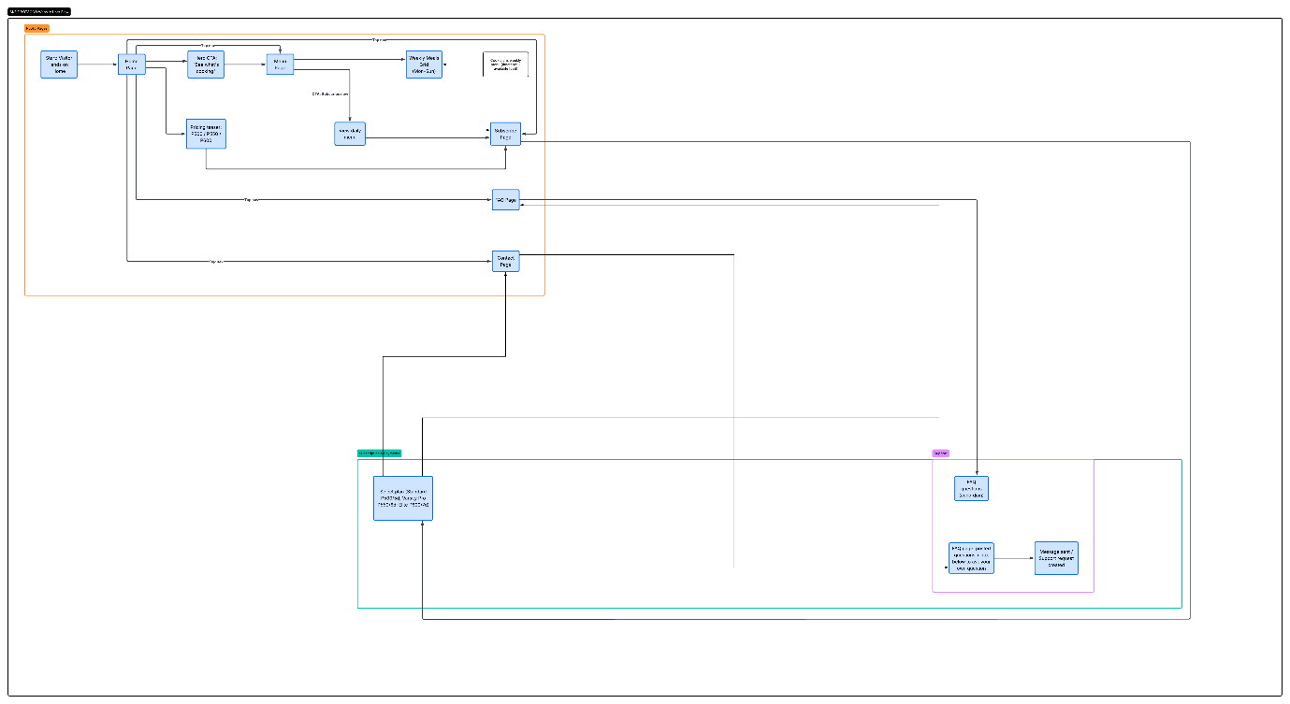

Public Pages (Orange Section)
This is the entry point for most users.
- Entry: Visitors land on the Home Page, which features a "See what's cooking" Call to Action (CTA).
- Information Gathering: Users can view the Menu Page, a Weekly Meals Grid, or a Pricing teaser (showing tiers like P500 and P600).
- Navigation: From the Home Page, users have direct links to the FAQ Page and Contact Page.

Selection & Payments (Teal Section)
This section handles the core business logic of the subscription service.
- Plan Selection: Once a user decides to subscribe, they move to the Subscribe Page where they select a specific plan, such as Standard (P500/5d), Varsity Pro (P550/6d), or Elite (P600/7d).
- Processing: This section connects the user's intent to the final payment or registration step.

Support (Pink/Purple Section)
This area is designed for user assistance and troubleshooting.
- Self-Service: The FAQ Page leads to an accordion-style list of common questions.
- Direct Inquiry: If the FAQ does not resolve their issue, users can use a text box to ask their own question, which then creates a support request.
- Page Template Design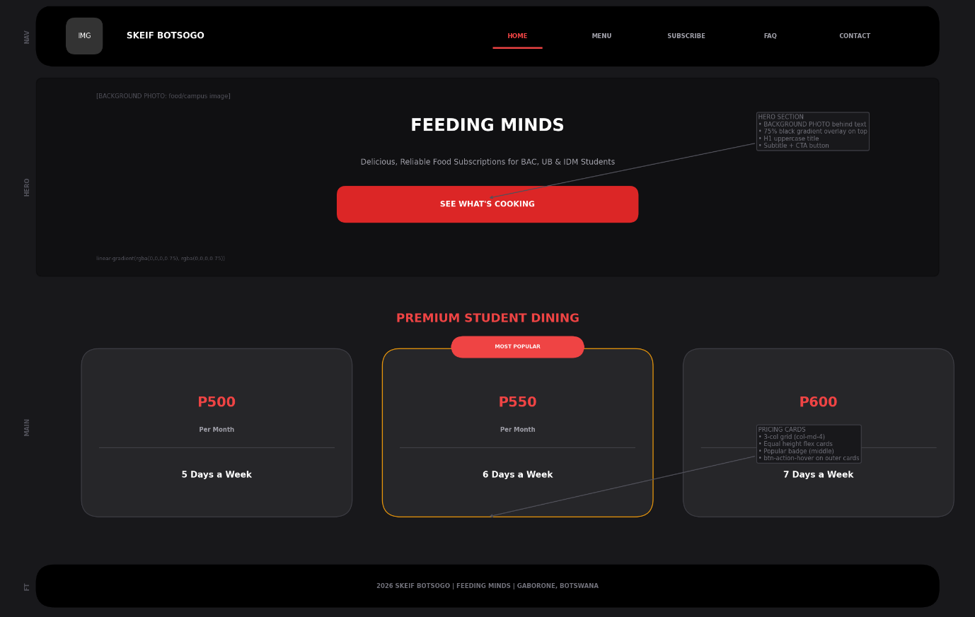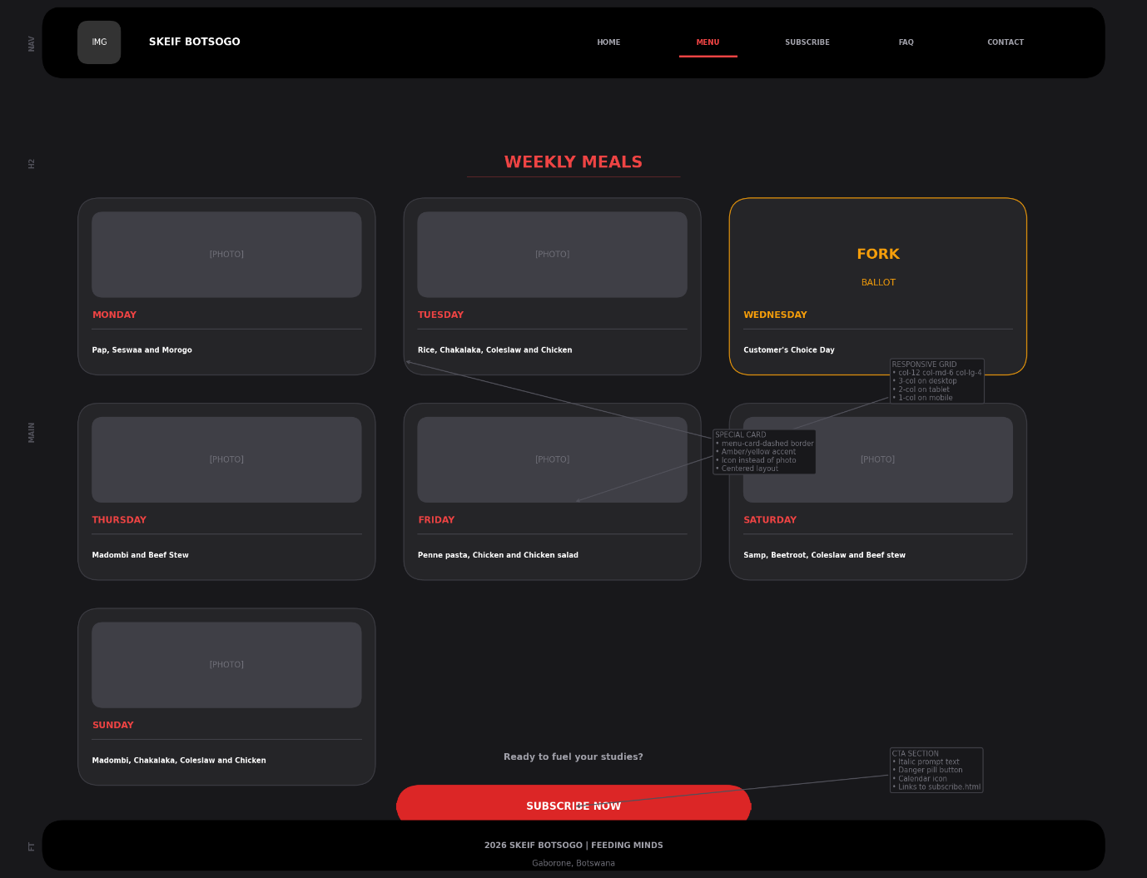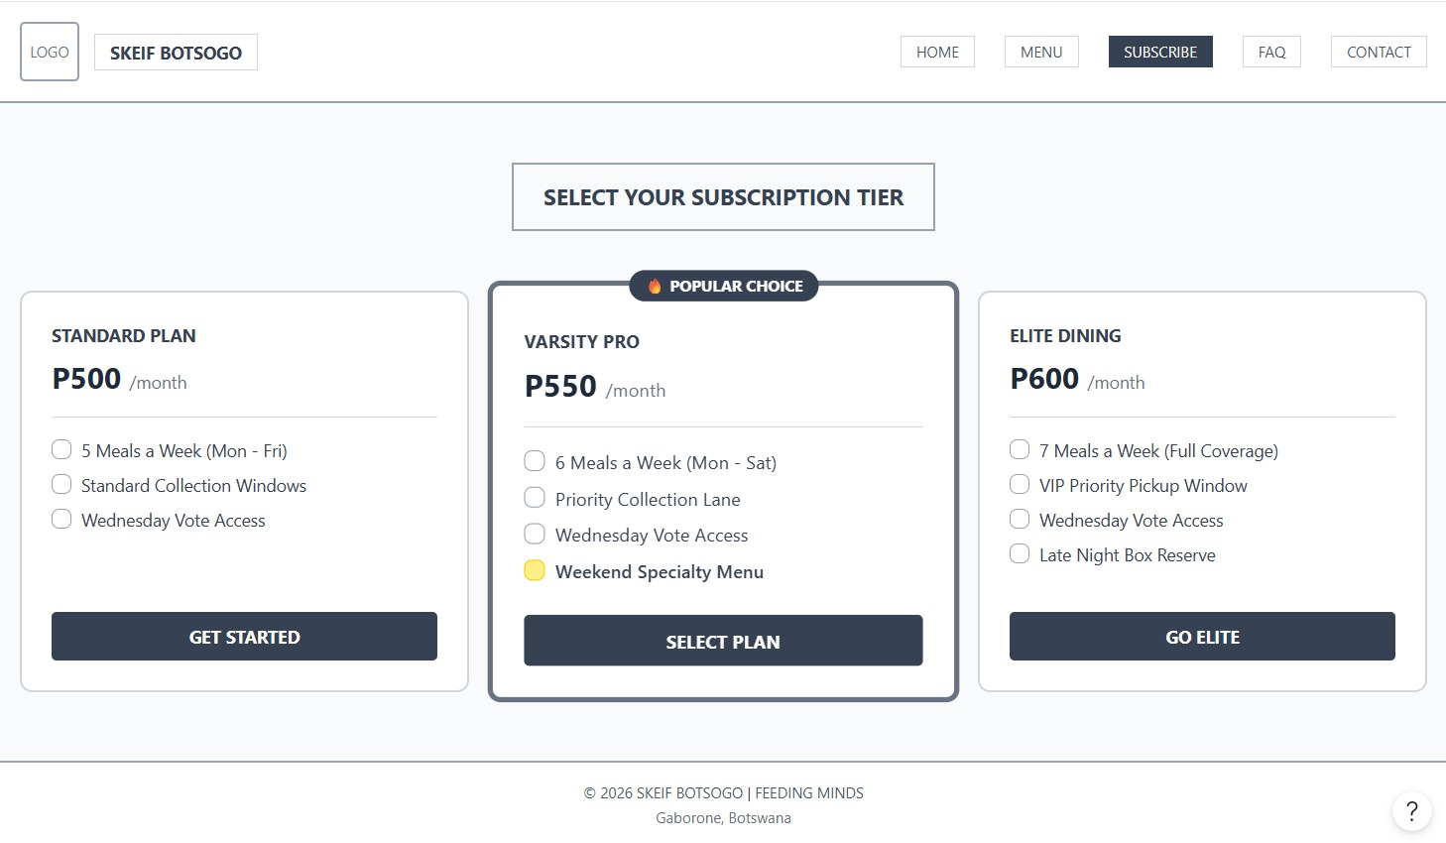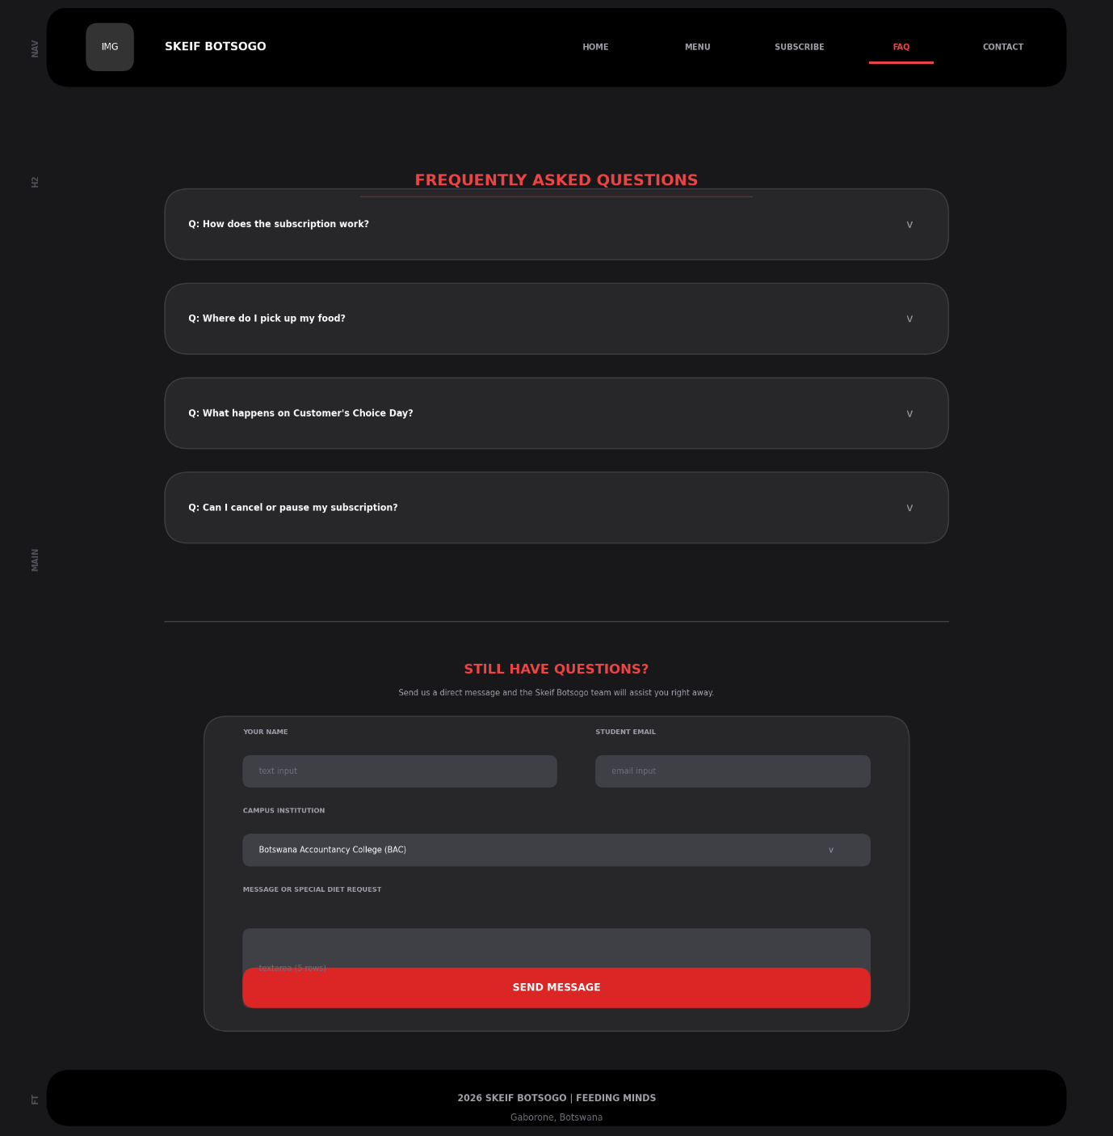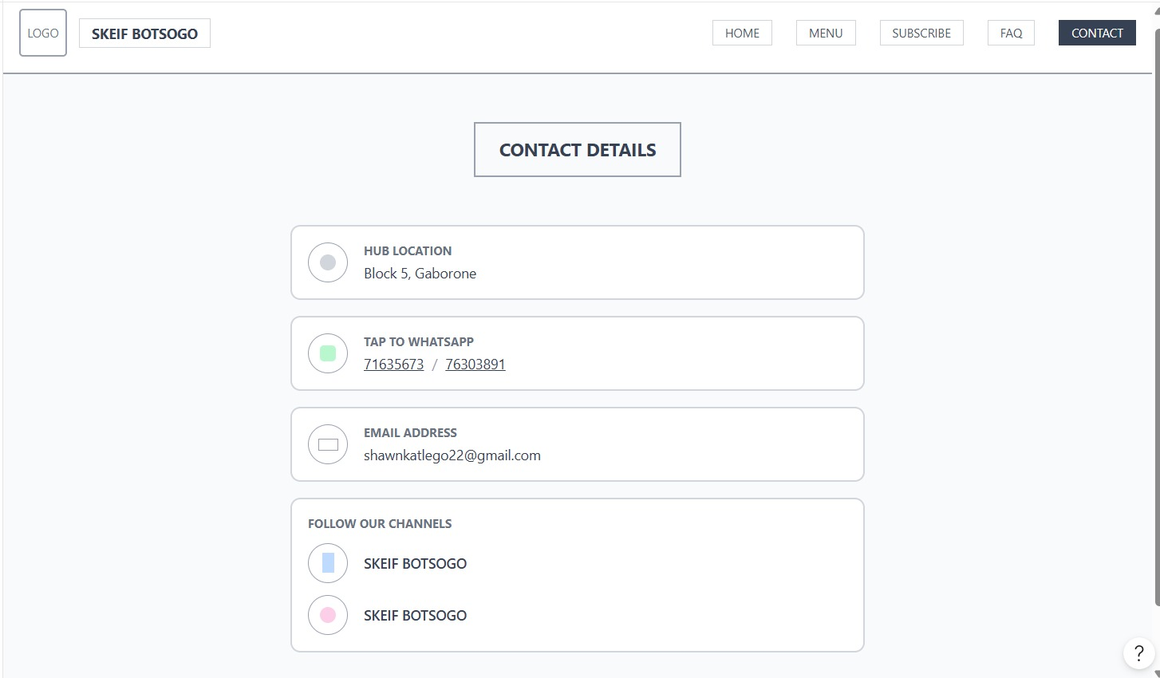

- Technical Brief
- Github to manage code updates and ensure project security.
- Lucidchart and Figma used to build the Sitemap and User Flowcharts for this documentation.
- HTML5 is use to structure layers of the website.
- CSS3 to present layer and styling.
- JavaScript for interaction and dynamic behavior.
- BootStrap5 for responsive frame work.

Quality Assurance

Browser compatability
Browser Engine | Target System OS | Pass/Fail
Google Chrome | Windows 11 /Andorid | PASS
Opera | Android | PASS
Microsoft Edge | Windows 11 | PASS
Apple Safari | iOS | PASS

Device compatability
Target Device Profile | Screen Resolution | Pass/Fail
Standard Desktop Monitor | 1920 * 1080 | PASS
Apple iPhone | 768 * 1024 | PASS
Modern Smartphone | 360 * 800 | PASS

Laptop and Google Chrome

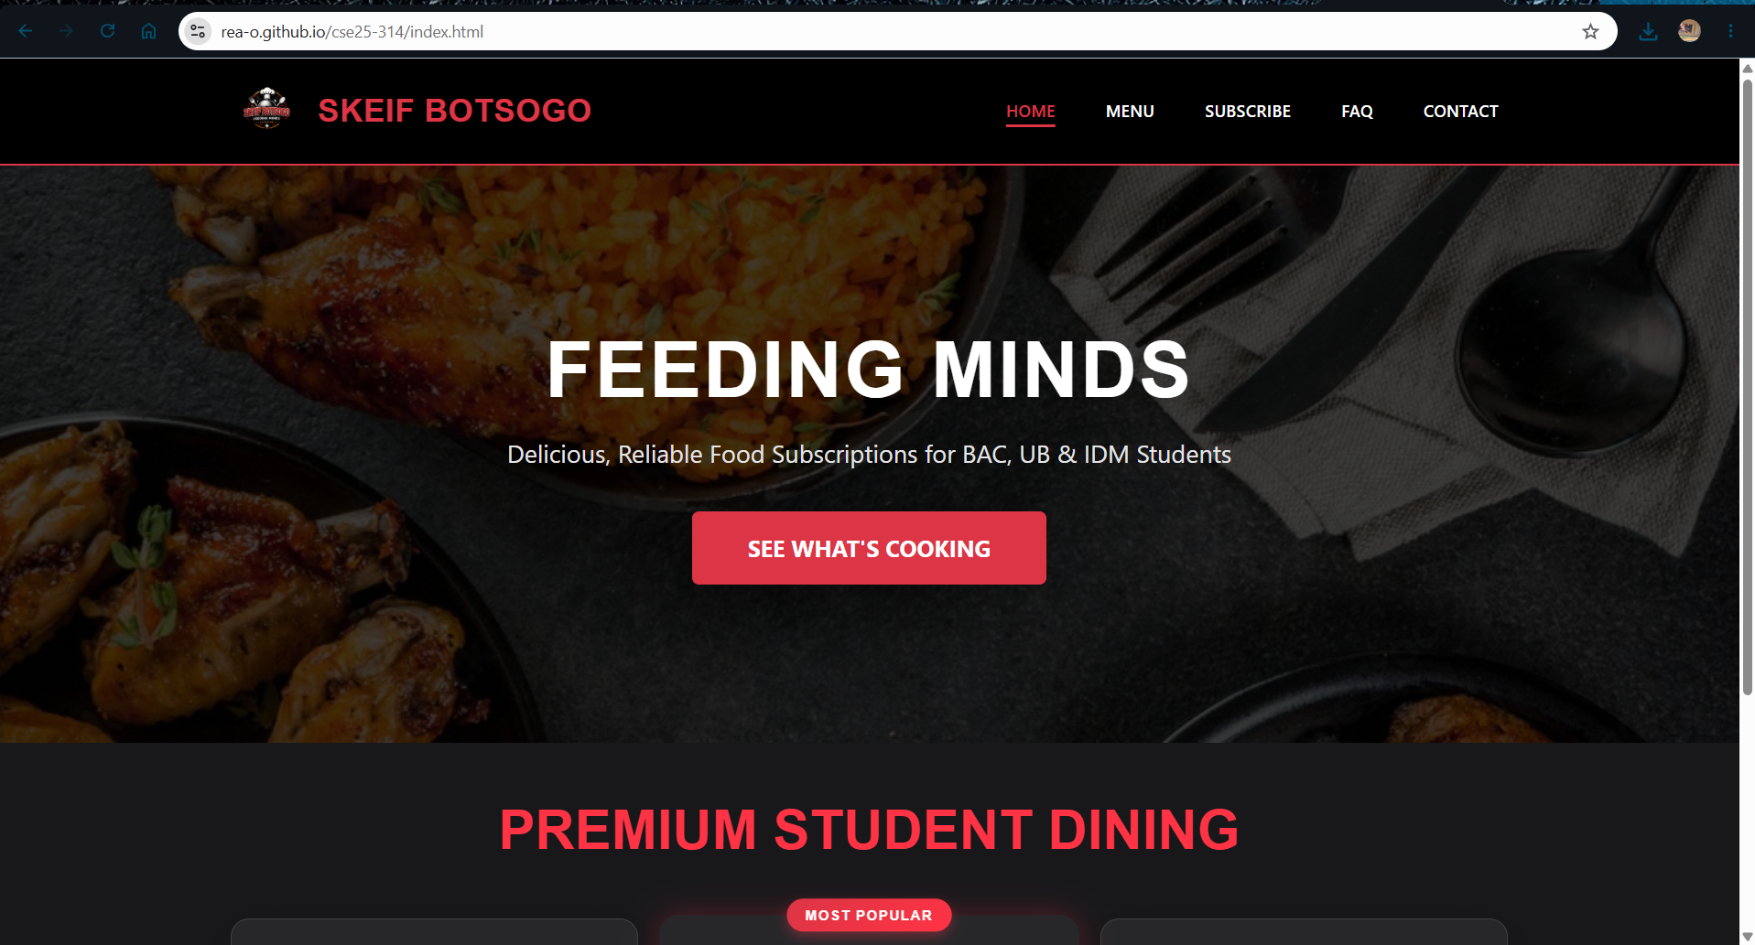

Laptop and Microsoft Edge

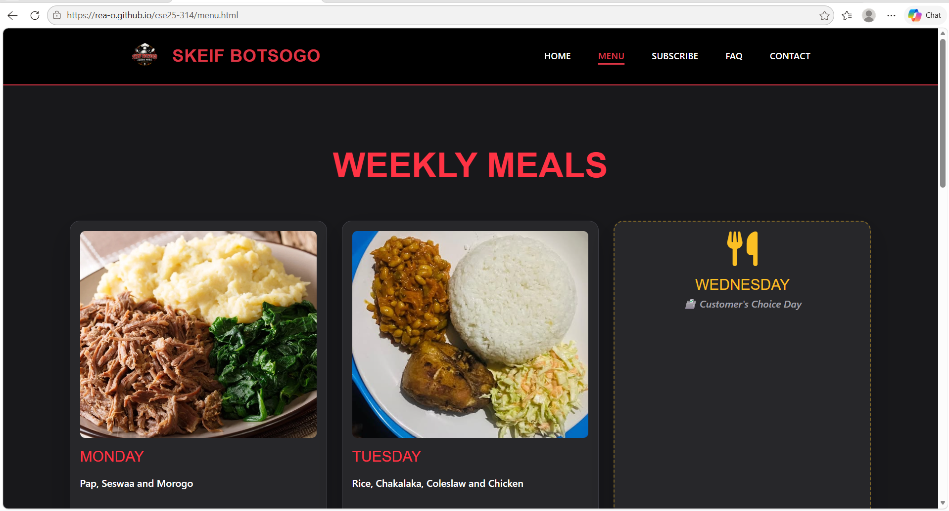

iPhone and Safari

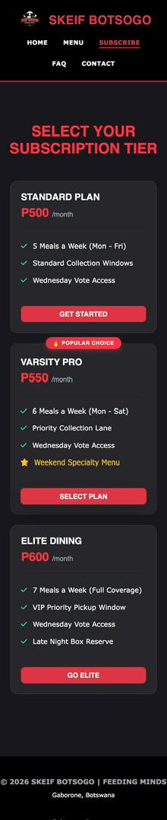

Google Chrome and Android

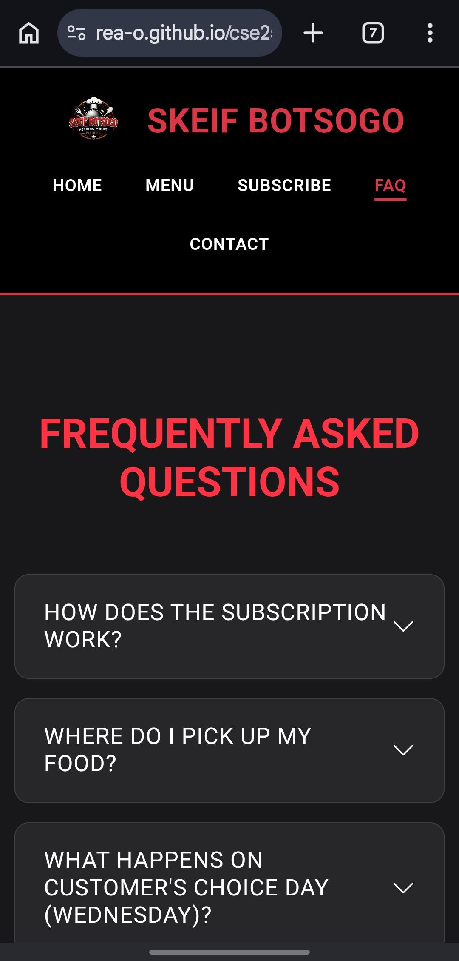

Android and Opera
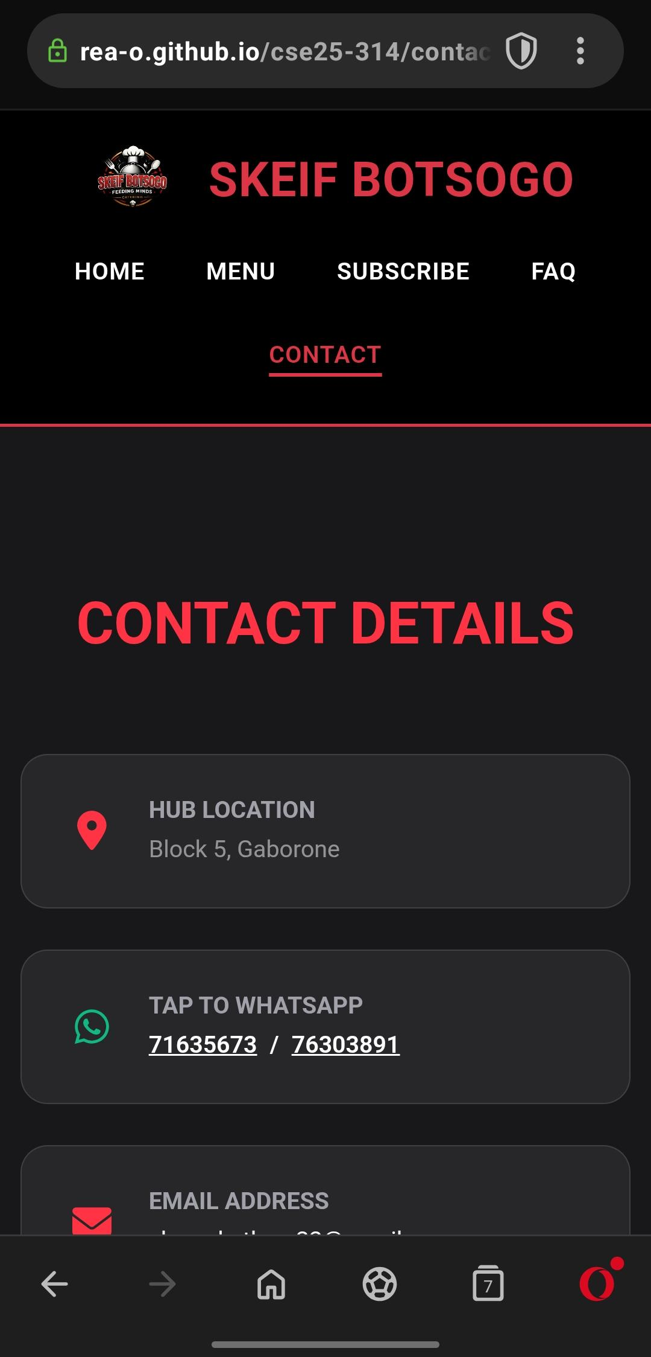

Publishing & Promotion

Step-by-Step Upload & Publishing Method
- Repository Creation: A new public cloud repository named skeif-botsogo was created directly on the GitHub website.
- Web Browser Upload: Using the "Upload files" feature on the GitHub interface, the complete project folder structure including all .html pages, the css/style.css stylesheet, code scripts, and image assets (logo.jpeg) was dragged, dropped, and committed directly into the main repository branch.
- Pages Activation: Navigated to the repository settings, accessed the pages sidebar tab, and configured the build source to automatically deploy from the main branch root directory.

Production Live Environment Access URL
Once the background compilation process finished, the target routing domain was assigned and configured at the live public endpoint address below for immediate student access:
Production Reference Link Address: https://rea-o.github.io/cse25-314/

Future Developments & Recommendations
- Dynamic Student Authentication & Database Binding: Migrate the static form layout into a secure server-side framework (such as Java Spring Boot) connected to a PostgreSQL database. This will allow students from BAC, UB, and IDM to securely log in and track their subscription status in real time.
- Real-Time Live WhatsApp Notification Webhooks: Integrate a programmable communications system (e.g., the Twilio WhatsApp Business API). This tool can automatically send dynamic order confirmations, daily pickup times, and active QR code meal ticket vouchers directly to a student's phone number.
- Integrated Payment Gateway Aggregation: Embed localized online billing solutions (such as Orange Money, BTC Smega, or local bank card portal gateways) straight into the subscription dashboard cards. This allows students to securely complete digital Pula transactions right on the website, eliminating the need to manually verify bank transfer receipts.

